Central Coast Health Promotion Service
Equipment Loan Form
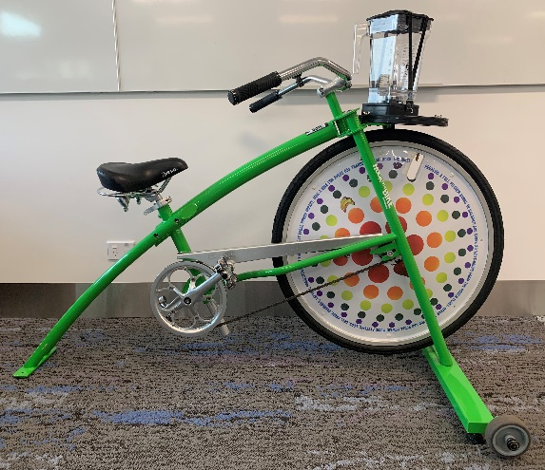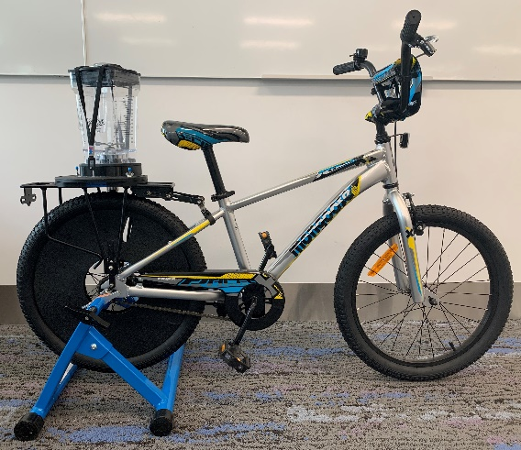
Adult Bike Kids Bike
Equipment is available for CCLHD departments, schools and other organisations to borrow for events to promote healthy eating and active living.
Please complete details below and return pages 1 and 2 via email to:
CCLHD-HealthPromotion@health.nsw.gov.au
Name:
Position:
Organisation/Department:
Email:
Phone:
Which Blender Bike are you borrowing: please tick
- Small ‘kids’ blender bike - (Fender Blender Universale - Early childhood blender bike (20” wheel size suitable for children 5-8 years of age or 120-135cm in height). Max rider weight 75kg
- Large ‘adult’ blender bike - (Fender Blender Pro - suitable for children 8 years of age or 135-145cm in height to adults). Max rider weight 100kg.

Borrowing start date: time:
Return date: time:
Are you flexible with dates? If so, please provide alternate date(s).
____________________________________________________________________________________________________________________________________________________________________
Conditions of loan:
- The borrower is required to read the user manual provided.
- The borrower is responsible for food safety, safe use and appropriate supervision of bike use.
- Liaise with Health Promotion Staff regarding safe transport of equipment and if collection or delivery is required
- Health Promotion Service address: Level 10, Building A (Central Coast Clinical School and Research Institute), 77A Holden St, Gosford. Enter off Racecourse Road, opposite Gosford High School
- Any damage to equipment is the responsibility of the borrower and must be reported at the time of returning equipment.
- The borrower must review and complete the ‘Blender bike checklist’ when receiving and returning the bike(s).
- The borrower accepts responsibility for costs incurred as a result of any damage to equipment loaned e.g. repair or replacement of damaged/missing parts. For an indication of prices, please visit: Shop | Rock The Bike. Note: Prices are in US$ and shipping costs need to be added.
- The borrower is responsible for the cleaning and safe storage of all equipment. Please return the bike and blenders thoroughly cleaned.
- Risk assessments are the responsibility of the borrower. The CCLHD Risk Assessment form is provided as a guide.
Transport and storage
- The adult blender bike can be tilted and rolled for short distances, on smooth, hard surfaces – it has wheels attached to the base.
- The adult blender bike must not be taken apart in any way for transport and a suitable vehicle is required
  - For example: it can be loaded into the boot of a van or large vehicle.
  - Bike dimensions are 143cm long, 100cm tall, 79cm wide.
- The kid's blender bike consists of a bike and stand. Please leave these connected. Bike dimensions are 135cm long, 103cm high and 56cm wide.
- Two people will be needed to transport the blender bike(s). Please refer to the Manual Handling Policy and Safe Work Method (see manual) for the CCLHD or your organisation’s equivalent when transporting either bike between locations.
- Store in a secure and dry place, away from direct sunlight
What is provided:
- The adult blender bike comes with a storage box containing pitchers/jugs x 2, User Manual and Toolkit (including the user manual, recipes, and tools).
- The kid’s blender bike includes 20” kids bike, stationary stand and comes with a storage box containing pitchers/jugs (x2) and User Manual.
- Both bikes come with the Blender Bike Checklist (see below) – please review this when receiving and returning the bike. The borrower is required to sign the checklist(s) and return it with the bike(s).
I agree to the Conditions of Loan on behalf of my organisation.
Signed: ____________________ Name: _____________________ Date: __________________
Blender Bike Checklist
This form will be completed when the borrower receives and returns the bike.
Name of organisation:
Contact person:
Email:
Phone:
Conditions of loan:
- The borrower is required to read the user manual provided.
- The borrower is responsible for food safety, safe use and appropriate supervision of bike use.
- Liaise with Health Promotion Staff regarding safe transport of equipment and if collection or delivery is required
- Health Promotion Service address: Level 10, Building A (Central Coast Clinical School and Research Institute), 77A Holden St, Gosford. Enter off Racecourse Road, opposite Gosford High School
- Any damage to equipment is the responsibility of the borrower and must be reported at the time of returning equipment.
- The borrower must review and complete the ‘Blender bike checklist’ when receiving and returning the bike(s).
- The borrower accepts responsibility for costs incurred as a result of any damage to equipment loaned e.g. repair or replacement of damaged/missing parts. For an indication of prices, please visit: Shop | Rock The Bike. Note: Prices are in US$ and shipping costs need to be added.
- The borrower is responsible for the cleaning and safe storage of all equipment. Please return the bike and blenders thoroughly cleaned.
- Risk assessments are the responsibility of the borrower. The CCLHD Risk Assessment form is provided as a guide.

Blender Bike Checklist – adult blender bike
Please complete the below table to describe the condition of the bike. Tick if parts are present and in good working condition and cross if not, or any concerns are noted. Please provide details of concerns noted.
 | Received by borrower  Date: ____ | Returned by borrower  Date: ____ | Received by CC Health Promotion Service  Date: ____ | Comments
Adult blender bike
Two Rock the Bike jugs/pitchers
Two black lids, with clear plastic inserts (to fit Rock the Bike jugs/pitchers)
Two measuring cups
Blender Bike User Manual
Toolkit (orange case) including:

15mm Rock The Bike spanner

Allen key set (x5)
Bike pump

- I confirm the bike and all parts are present and in good working order
Do you have any comments about the bike or the hiring process?
Signed:
Contact number:
Thank you for your assistance in returning the bike clean and complete, ready for others to use!

Adult Blender Bike Equipment
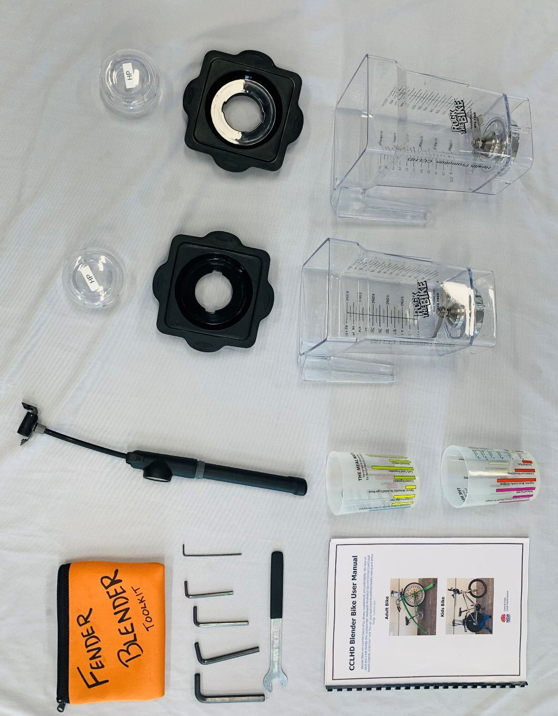

Blender Bike Checklist – kids blender bike
Please complete the below table to describe the condition of the bike. Tick if parts are present and in good working condition and cross if not, or any concerns are noted. Please provide details of concerns noted.
 | Received by borrower  Date: ____ | Returned by borrower  Date: ____ | Received by CC Health Promotion Service  Date: ____ | Comments
Kid’s blender bike
composed of:
-20” kids bike (silver Mongoose BMX)
-Stationary stand (blue Rock the Bike)
Two Rock the Bike jugs/pitchers
Two black lids, with clear plastic inserts (to fit Rock the Bike jugs/pitchers)
Two measuring cups
Blender Bike User Manual
Bike pump
Kids bike toolkit (orange case) - contains an Allen key
- I confirm the bike and all parts are present and in good working order
Do you have any comments about the bike or the hiring process?
Signed:
Contact number:
Thank you for your assistance in returning the bike clean and complete, ready for others to use!

Kids Blender Bike Equipment

